|  |
| --- |
|  |

**Department of Electrical, Electronics and Communication Engineering**

Basic Electrical and Electronics Engineering

**Lab Manual**

[G2UC120B]

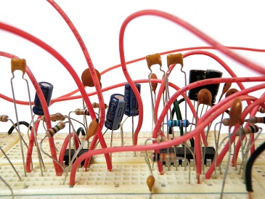

**BEEE LAB**

**Faculty In Charge Approved By:HOD(DEECE)**

**Dr. Dipak Kumar Ghosh Prof. Dr. Lokesh Varshney**



**Department of Electrical, Electronics and Communication Engineering**

|  |  |
| --- | --- |
| In-Charge | Name |
| H.O. D | Prof. Dr. Lokesh Varshney |
| Programme Chair | Dr. Sheetla Prasad |



**Department of Electrical, Electronics and Communication Engineering**

University Vision

“To be known for world-class education, cutting-edge research, innovation, and application of knowledge to benefit society.”

University Mission

M1: To provide high-quality education, knowledge and skills necessary for our students to be successful in the technologically evolving world.

M2: To provide a supportive learning environment that facilitates discovery of new knowledge and continuous innovation

M3: To instil a culture of interdisciplinary enquiry and education that facilitates generation of cutting-edge solutions to real-world problems.

M4: To foster an environment that inculcates skills in life-long learning and team-based problem solving.



**Department of Electrical, Electronics and Communication Engineering**

Department Vision

“To be known globally as a premier department of Electronics and Communication Engineering for value-based education and interdisciplinary research for innovation.”

Department Mission

SM1: Create a strong foundation on fundamentals of Electronics and Communication Engineering through Outcome Based Learning Teaching (OBLT) Process.

SM2: Establish state-of -the-art facilities for design and simulation.

SM3: Provide opportunities to students to work on real world problems and develop sustainable ethical solutions.

SM4: Involve the students in group activities, including those of professional bodies to develop leadership and communication skills.



**Department of Electrical, Electronics and Communication Engineering**

**Programmed Outcome (PO)**

**PO1:** Engineering knowledge: Apply the knowledge of mathematics, science, engineering fundamentals, and an engineering specialization to the solution of complex engineering problems. PO2: Problem analysis: Identify, formulate, review research literature, and analyze complex engineering problems reaching substantiated conclusions using first principles of mathematics, natural sciences, and engineering sciences.

**PO3:** Design/development of solutions: Design solutions for complex engineering problems and design system components or processes that meet the specified needs with appropriate consideration for the public health and safety, and the cultural, societal, and environmental considerations.

**PO4:** Conduct investigations of complex problems: Use research-based knowledge and research methods including design of experiments, analysis and interpretation of data, and synthesis of the information to provide valid conclusions.

**PO5:** Modern tool usage: Create, select, and apply appropriate techniques, resources, and modern engineering and IT tools including prediction and modeling to complex engineering activities with an understanding of the limitations.

**PO6:** The engineer and society: Apply reasoning informed by the contextual knowledge to assess societal, health, safety, legal and cultural issues and the consequent responsibilities relevant to the professional engineering practice.

**PO7:** Environment and sustainability: Understand the impact of the professional engineering solutions in societal and environmental contexts, and demonstrate the knowledge of, and need for sustainable development.

**PO8:** Ethics: Apply ethical principles and commit to professional ethics and responsibilities and norms of the engineering practice.

**PO9:** Individual and team work: Function effectively as an individual, and as a member or leader in diverse teams, and in multidisciplinary settings.

**PO10:** Communication: Communicate effectively on complex engineering activities with the engineering community and with society at large, such as, being able to comprehend and write effective reports and design documentation, make effective presentations, and give and receive clear instructions.

**PO11:** Project management and finance: Demonstrate knowledge and understanding of the engineering and management principles and apply these to one’s own work, as a member and leader in a team, to manage projects and in multidisciplinary environments.

**PO12:** Life-long learning: Recognize the need for, and have the preparation and ability to engage in independent and life-long learning in the broadest context of technological change.



**Department of Electrical, Electronics and Communication Engineering**

COURSE OBJECTIVES

1. Verifying and analyzing the practical network circuits.
2. Use of basic laboratory equipment and procedure to measure electrical quantities using laboratory test equipment such as multimeters, power supplies etc.
3. Analyzing and solving different electrical and electronic circuits by applying different laws.
4. Evaluate the performance of electrical and electronic circuits.

COURSE OUTCOMES

On completion of this course, the students will be able to

CO 1: Handle of basic electrical and electronics equipment’s.

CO 2: Measure electrical quantities and calculate various parameters.

CO 3: Understand and analyze the performance of various circuit connections.

CO 4: Design of basic electronic circuits and systems.

CO 5: Analyze the fundamental concepts involving electrical and electronics engineering.

CO6: Simulation of basic electronics circuits

CO-PO Mapping

|  |  |  |  |  |  |  |  |  |  |  |  |  |  |  |  |  |
| --- | --- | --- | --- | --- | --- | --- | --- | --- | --- | --- | --- | --- | --- | --- | --- | --- |
| Basic Electrical  and Electronics Engineering Lab  (BEE01T1003) | | Engineering Knowledge | Problem analysis | Design/development of solutions | Conduct investigations of complex problems | Modern tool usage | The engineer and society | Environment and sustainability | Ethics | Individual or team work | Communication | Project management and finance | Life-long Learning | PSO 1 | PSO 2 | PSO 3 |
| COs | | 1 | 2 | 3 | 4 | 5 | 6 | 7 | 8 | 9 | 10 | 11 | 12 | 13 | 14 | 15 |
| 1 | Handle of basic electrical and electronics equipment’s. | 3 | 3 | 2 |  |  |  |  |  | 3 |  |  | 3 | 3 |  |  |
| 2 | Measure electrical quantities and calculate various parameters. | 3 | 3 | 3 |  |  |  |  |  |  |  |  |  |  |  |  |
| 3 | Understand and analyze the performance of various circuit connections. | 3 | 3 | 3 |  |  |  |  |  | 3 |  |  | 3 | 3 |  |  |
| 4 | Design of basic electronic circuits and systems | 3 | 3 | 2 | 3 |  |  |  |  | 3 |  |  | 2 | 3 |  |  |
| 5 | Analyze the fundamental concepts involving electrical and electronics engineering. | 3 | 3 | 3 | 1 |  |  |  |  | 3 |  |  | 1 | 3 |  |  |
| 6 | Simulation of basic electronics circuits | 2 | 2 | 2 |  |  |  |  |  |  |  |  | 1 | 1 |  |  |



Department of Electrical, Electronics and Communication Engineering

**Mode of Evaluation**

|  |  |  |
| --- | --- | --- |
| Components | Laboratory | |
| Internal Examination | End Term Examination |
| Marks | 20 | Marks |
| Total Marks | 40 | |

**Details Evaluation Scheme:**

|  |  |  |  |
| --- | --- | --- | --- |
| Component of evaluation | Evaluation | Rubric for CO | Marks |
| Experiment understanding | Internal | Design process | 5 |
| Performance | Discussion of results | 5 |
| Record | Quality of sketch, drawing and graphs | 5 |
| Internal viva | Theory, tools, &team works | 5 |
| Lab experiment | End term | Design process | 5 |
| Lab Report | Quality of sketch, drawing and graphs | 5 |
| Viva by external expert | Theory, tools, &team works | 10 |
| Total | | | 40 |



**Department of Electrical, Electronics and Communication Engineering**

**BEEE Lab Assessment Process-**

* Faculty members must carry the attendance register.
* Before coming to class faculty members must have ensured the students get the lab manual.
* Clearly define the lab problem to the students and the expected outcome of the experiment.
* Clearly explain the objective and theory behind the lab experiments.
* All faculty members in a lab class shall actively participate in the lab experiment giving guidance to students.
* Faculty members must check the results obtained by each student and sign on it.
* Faculty members must correct the error in results and instruct student to do necessary modification in experiment to get the correct results.
* Faculty must take a note of any mal functioning of equipment or component if found during the tour of lab.
* Faculty must check and correct the student’s lab records.
* Faculty members evaluate the student’s performance in the lab class as a part of continuous evaluation.
* Faculty must give the assignment or lab problem to students for lab-based solutions and shall assess the course outcomes based on performance of students.
* Faculty must ensure that each student endorse the following and upload in Moodle;
  + Preparation of data table and plot the graphs
  + students must explain data in table or graphs
  + Students must write the observation on data pattern or behavior of graphs.
  + Students must write the scientific justification of data variation or graphs behavior.
  + Students must write the error in results if any obtained during experiment.
* One course file is to be maintained for each course and all faculties must put the necessary documents of practice in the course file time to time.
* Faculty must declare the title of next experiment and must the students to go through lab manual before coming to lab.
* Faculty members must do the counseling to students who were absent in last class and instruct them to complete missed out experiment in extra time, otherwise the student will lose the marks.



**Department of Electrical, Electronics and Communication Engineering**

Do and Don’ts

|  |  |
| --- | --- |
| **Do** | **Don’ts** |
| • Proper Dress Has to Be Maintained While Entering in The Lab.  • Students Should Carry Observation Notes and Record Completed in All Aspects.  • Correct Specifications of The Equipment Have to Be Mentioned in The Circuit Diagram.  • Student Should Be Aware of Operating Equipment.  • Students Should Be at Their Concerned Experiment Table, Unnecessary Moment Is Restricted.  • Student Should Follow the Indent Procedure to Receive and Deposit the Equipment from The Lab Store Room.  • After Completing the Connections Students Should Verify the Circuits by The Lab Instructor.  • The Readings Must Be Shown to The Lecturer In-Charge for Verification.  • Before Leaving the Lab, Students Must Ensure That All Switches Are in The Off Position and All the Connections Are Removed. | • Don’t Come Late to The Lab.  • Don’t Enter into The Lab with Golden Rings, Bracelets and Bangles.  • Don’t Make or Remove the Connections with Power On.  • Don’t Switch on The Supply Without Verifying by The Staff Member.  • Don’t Switch Off the Machine with Load.  • Don’t Leave the Lab Without the Permission of The Lecturer In- Charge. |



**Department of Electrical, Electronics and Communication Engineering**

**LIST OF EXPERIMENTS**

**Basic Electrical and Electronics Engineering Lab**

|  |  |  |
| --- | --- | --- |
| **EXPERIMENT LIST** | | |
| **S. No.** | **Objective** | |
| **1** | **To familiarize with Electrical and Electronics lab equipment’s, basic electronics components.** | |
| **2** | **To verify the (a) Kirchhoff’s current law and (b) Kirchhoff’s voltage for the given circuit.** | |
| **3** | **To verify the Thevenin’s Theorem for the given circuit.** | |
| **4** | **To verify the Norton’s Theorem for the given circuit.** | |
| **5** | **To verify and observe the given waveform (Sinusoidal/Square/Triangular) and calculate its Frequency, Peak Value, Average Value, RMS Value and Form factor** | |
| **6** | **To plot the V-I Characteristics of P-N Junction Diode and calculate the forward and reverse resistance of the Diode.** | |
| **7** | **To plot the V-I Characteristics and Verification of Regulation action of ZENER Diode, for forward and reverse resistance of the Diode.** | |
| **8** | **To verify the working of Half and Full Wave Rectifier Circuit and calculate its efficiency.** | |
| **9** | **To plot the input and output characteristics of Bipolar Junction Transistor (BJT) in Common Emitter connection.** | |
| **10** | **Project – Students should be encouraged to make a working model/Project to demonstrate any Transducer/Sensor action or any related field.** | |
| **HOD**  **(DEECE)**  **Dr. Lokesh Varshney** | |

EXPERIMENT 1

**OBJECTIVE:** To familiarize with Electrical and Electronics lab equipment’s, basic electronics components.

THEORY:

There are many electronic components like Resistors, Capacitors, LEDs, Transistors, etc. and there is also many equipment like a Power Supply, Oscilloscope, Function Generator (or Signal Generator), Multimeter, etc.

Basic Electronic Components

There are many ways to classify different types of electronic components but the most common way is to classify them in to three types:

1)Active Electronic Components,

2)Passive Electronic Components and

3)Electromechanical Components.

### Active Electronic Components

Parts of a circuit that rely on an external power source to control or modify electrical signals.

#### [Diodes](https://www.electronicshub.org/applications-of-diodes/)

A diode is a non-linear semiconductor device, that allows the flow of current in one direction. A Diode is a two – terminal device and the two terminals are Anode and Cathode respectively.

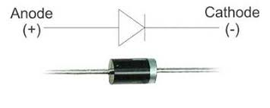 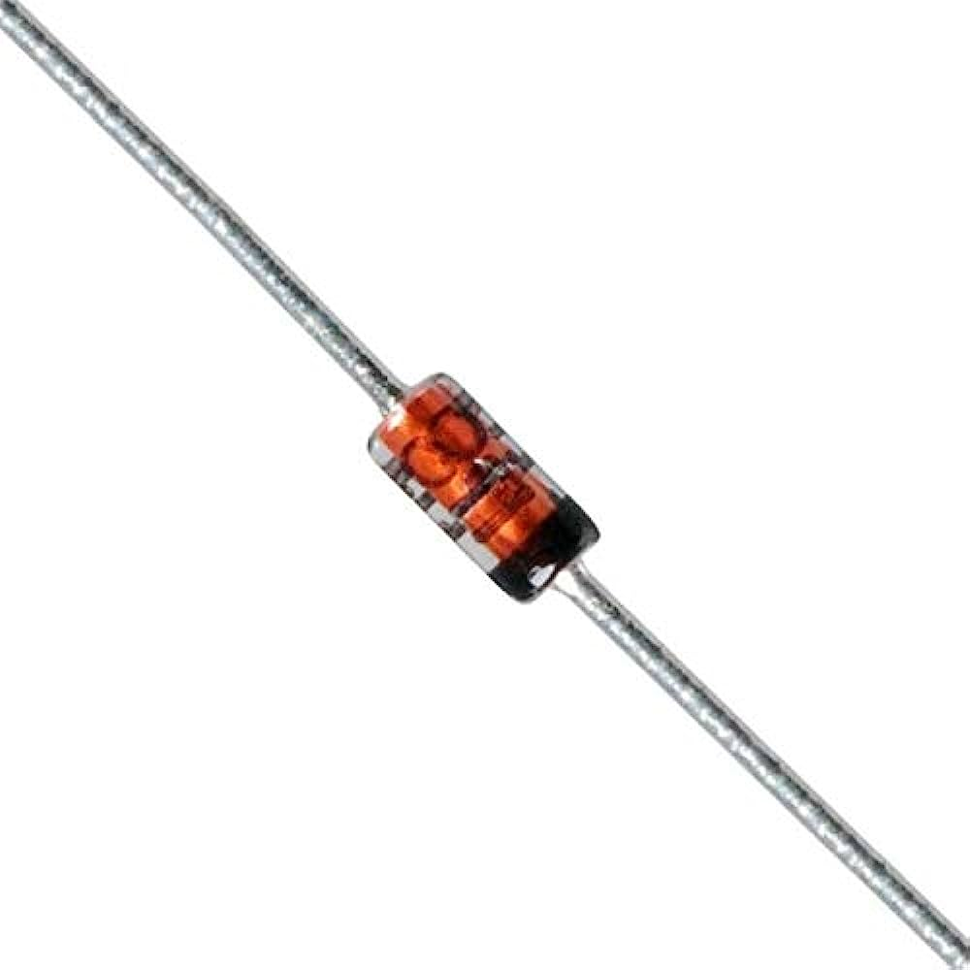

**Zener Diode:**

Mostly used as voltage reference diodes.

**Transistors:**

Transistor, the invention that changed the future of electronic circuits. It is a semiconductor device that can be used to either switch electrical power or amplify electronic signals.

A Transistor is a 3 terminal device that can be either a current controlled device or a voltage-controlled device. Different [types of transistors](https://www.electronicshub.org/transistors-classification-and-types/) exists. Basically, they are classified as

1) Bipolar Junction Transistors (BJT) and  
2) Field Effect Transistors (FET).

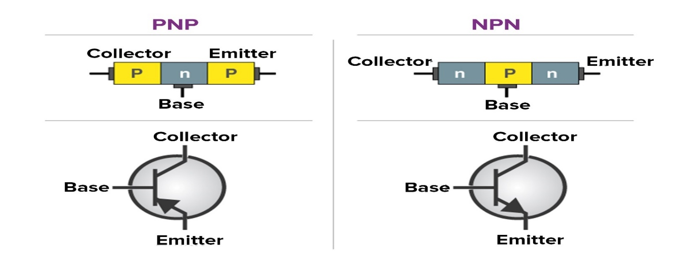

##### **DC Power Supply:**

Bench Power Supply is an important piece of equipment when it comes to working around electronic circuits. Electronic components majorly work on DC Power Supply and hence having a reliable source of DC Power Supply is very important.

There are many types of Power Supplies like AC – to – DC Power Supplies, Linear Regulators, Switching Mode Power Supply, etc. An alternative to bench power supply is to use a wall adapter as per the project requirement like 5V or 12V.

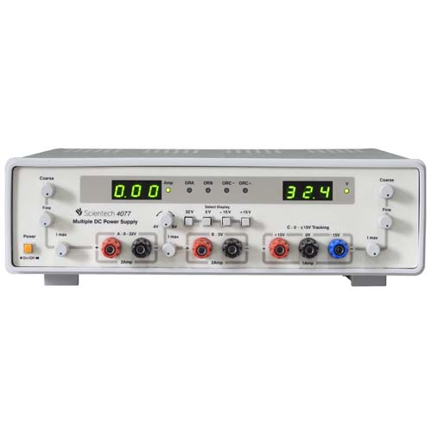 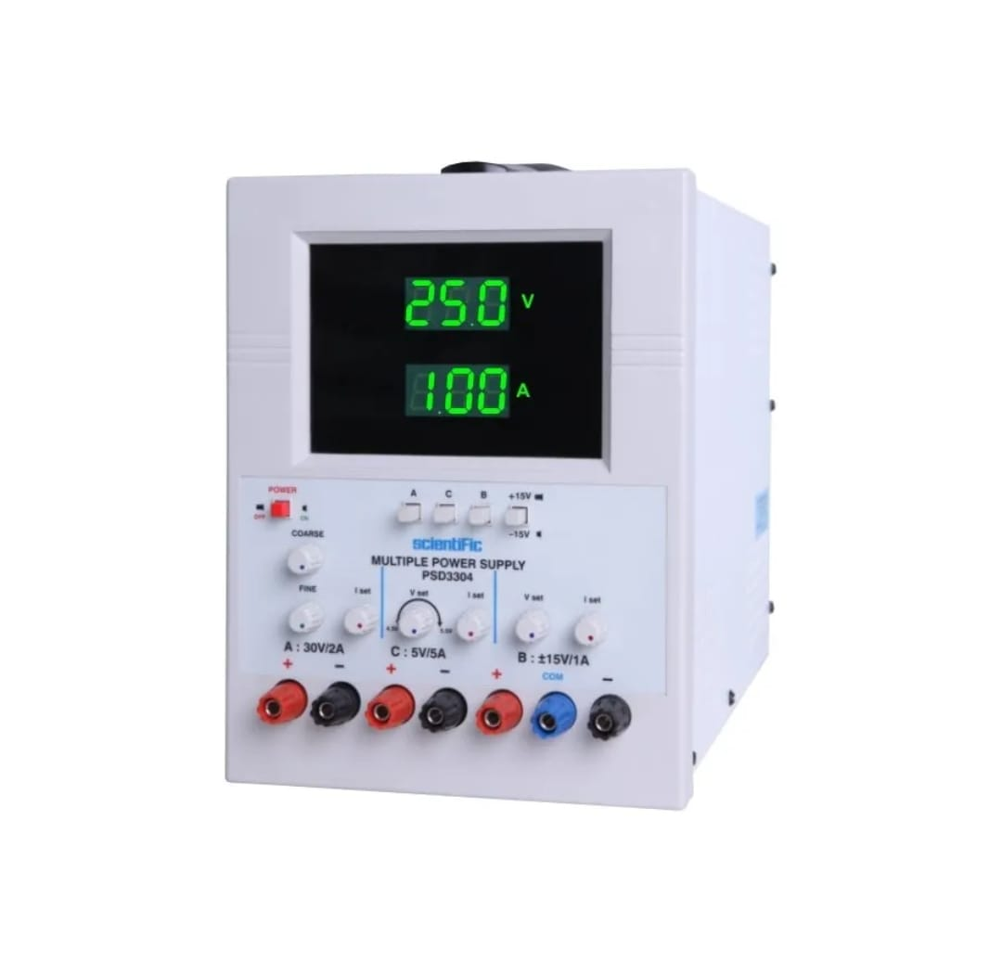

### Passive Components

Passive Components cannot control the flow of current through them i.e. they cannot introduce energy in to the circuit but can increase or decrease voltage and current.

These components don’t depend on the energy source for their operation. Two terminal components like Resistors, Capacitors, Inductors and transformers are examples of Passive Components.

#### Resistors:

The basic of all electronic components are the Resistors. It is a passive electronic component that introduces electrical resistance in to the circuit. Using resistors, we can reduce the current, divide voltages, setup biasing of transistors (or other active elements), etc.

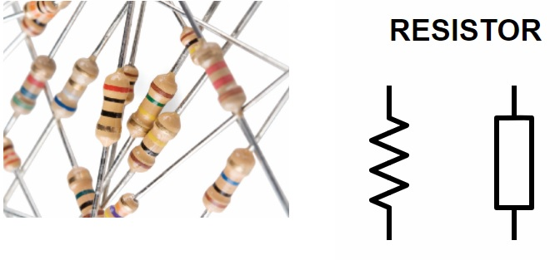

**Resistance color:**

Resistor color code is used to easily identify a resistor's resistive value and its percentage tolerance. Another way, the resistor uses the color-painted bands to indicate both their resistive value and their tolerance with the physical size of the resistor indicating its wattage rating. 4 bands resistors - The 4 band color code is the most common variation. These resistors contain two bands for resistance value, one multiplier, and one tolerance.

Tolerance color - Here the tolerance color is gold; therefore, the tolerates is 5%.

Therefore,

The maximum resistance value is

47000 + 47000⨯5% = 49350

The minimum resistance value is

47000 － 47000 ⨯ 5% = 44650

Then using our above example, we understood the value of the resistance is between 44650Ω to 49650Ω.

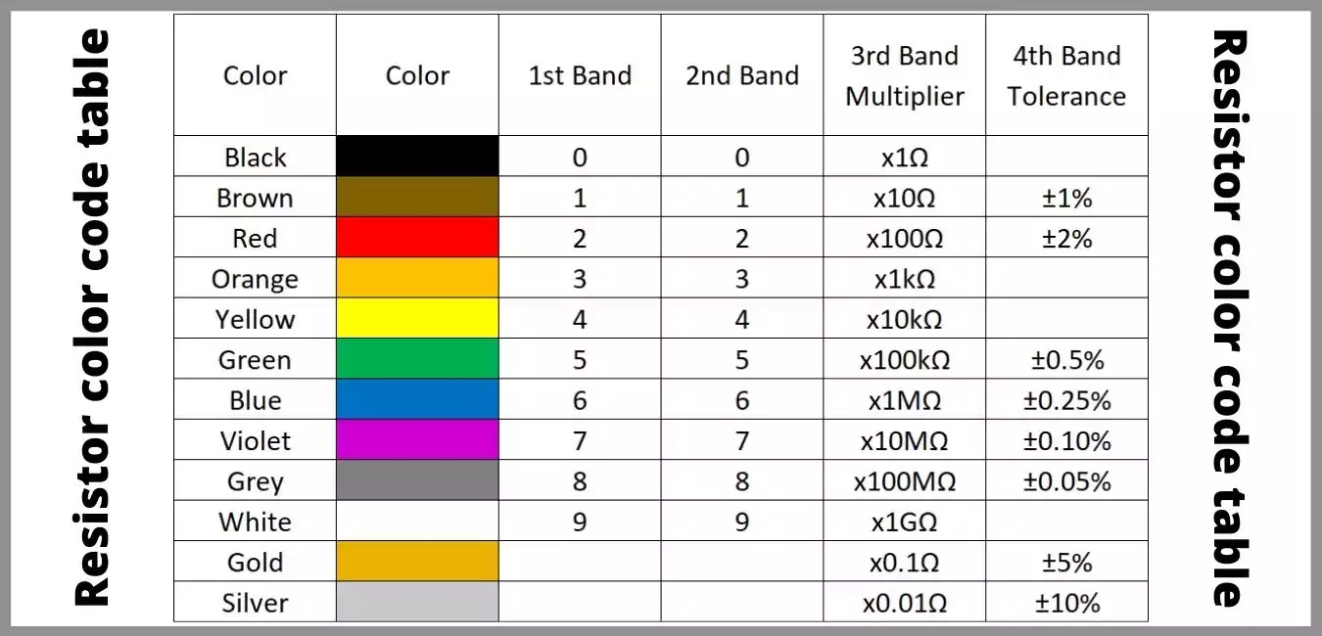

#### Capacitors:

The second important passive components is a capacitor, a device that stores energy in the form of [electric field](https://www.electronicshub.org/basics-of-electric-field/). Most capacitors consist of two conducting plates that are separated by a dielectric material.

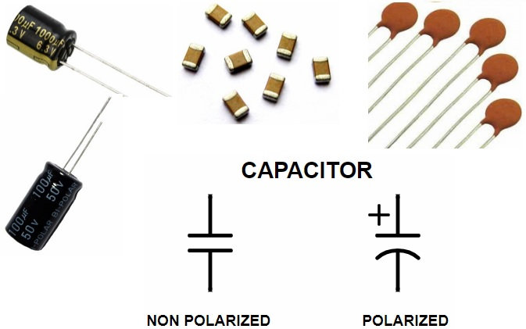

In electronics circuits, a capacitor is mainly used to block DC Current and allow AC Current. The other [applications of capacitors](https://www.electronicshub.org/applications-of-capacitors/) are filters, timing circuits, power supplies and energy storing elements.

There are many [types of Capacitors](https://www.electronicshub.org/types-of-capacitor/) like Polarized, Non – Polarized, Ceramic, Film, Electrolytic, Super Capacitors etc.

**Inductors:**

If capacitors store energy in the form of electric field, then inductors are devices that store energy in the form of Magnetic Field. Inductor is nothing but a wire that is wound in the form of a coil.

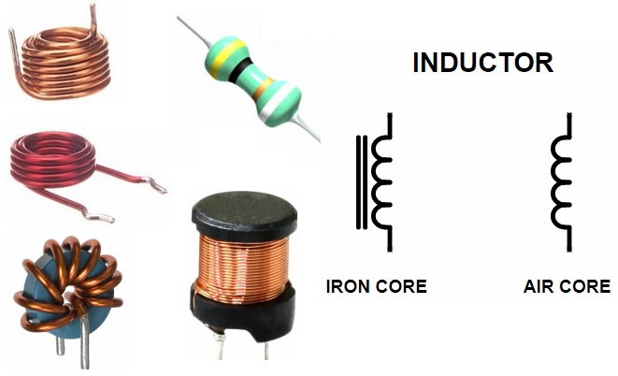

### Basic Test and Measurement Equipment

**Oscilloscope:**

An oscilloscope is a type of electronic test instrument that graphically displays varying voltages of one or more signals as a function of time.

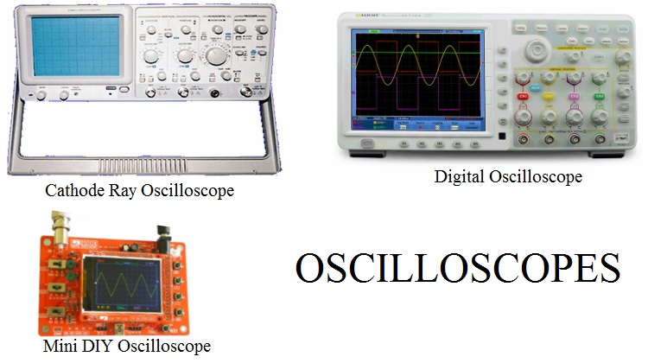

Multimeter:

A multimeter is a combination of Voltmeter, Ammeter and Ohmmeter. They provide an easy way to measure different parameters of an electronic circuit like current, voltage etc.

Multimeters can measure values in both AC and DC. Earlies Multimeters are Analog and consists of a pointing needle. Modern Multimeters are Digital and are often called as Digital Multimeters or DMMs

 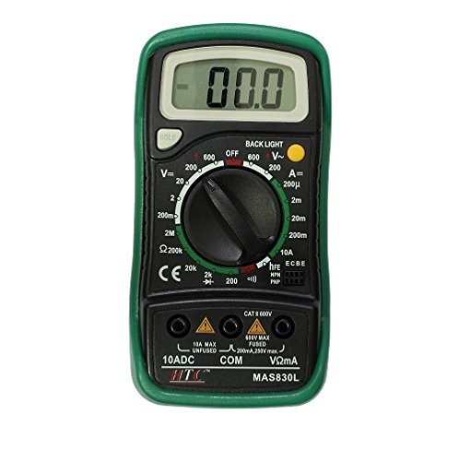

#### Function Generator or Signal Generator

A Signal Generator, as the name suggests, generates a variety of signals for testing and troubleshooting electronic circuits. The most common types of signals are Triangular Wave, Sine Wave, Square Wave and Sawtooth Wave.

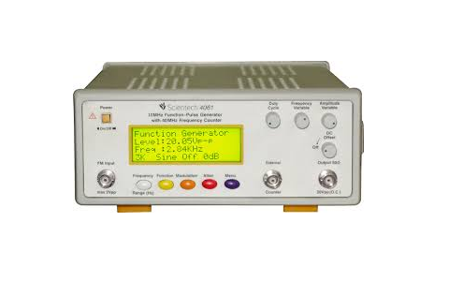 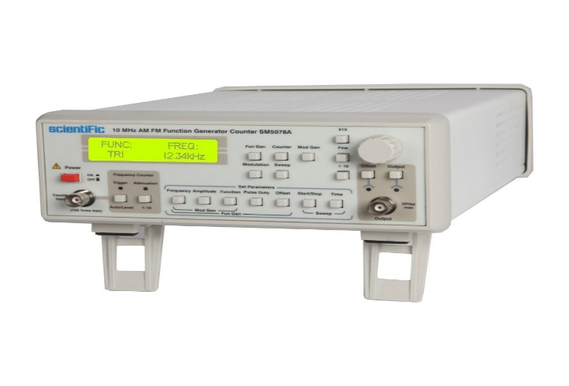

Along with a bench power supply and oscilloscope, a function generator is also an important piece of equipment when designing electronic circuits.

In this article, we have seen few Basic Electronic Components and Test Equipment that we come across very frequently when designing or testing electronic circuits.

There are a lot more components like Transformers, Buttons, Switches, Connectors, etc. which we can explore as we move forward with a project.

OBSERVATION TABLE:

|  |  |  |  |  |  |
| --- | --- | --- | --- | --- | --- |
| S. No. | Resistor | Color Band | Calculated Value of “R” (Ohm) | Measured Value of “R” (Ohm) | Remark |
| 1. | R1 | 1.  2.  3.  4. |  |  |  |
| 2. | R2 | 1.  2.  3.  4. |  |  |  |
| 3. | R3 | 1.  2.  3.  4. |  |  |  |
| 4. | R4 | 1.  2.  3.  4. |  |  |  |

CALCULATIONS:

QUESTIONS:

1. What are the types of resistors?
2. Why is tolerance value important in resistors?
3. What do you mean tolerance?
4. What do you understand by tolerance value in case of resistors?



EXPERIMENT 2(a)

AIM: To verify the Kirchhoff’s current law (KCL).

OBJECTIVE: The objective of this Lab activity is to verify Kirchhoff's Current Law (KCL) using mesh and nodal analysis of the given circuit.

THEORY: According to Kirchhoff’s current law, in any network of wires carrying currents, the algebraic sum of all currents meeting at a junction (or node) is zero or the sum of incoming currents towards any junction (or node) is equal to the sum of outgoing currents away from that junction.

APPARATUS REQUIRED:

|  |  |  |  |
| --- | --- | --- | --- |
| S. No. | Equipment | Specification | Quantity |
| 1. | Regulated power DC Supply | 0-30V | 1 |
| 2. | PMMC Ammeter | 0-1A | 1 |
| 3. | Resistances/Rheostats |  | 1 |
| 4. | Connecting Wires |  |  |

CIRCUIT DIAGRAM:

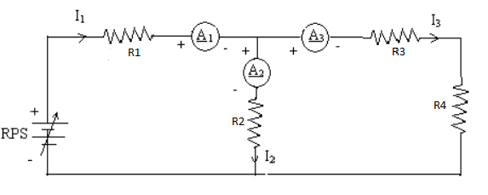

Figure 1 Circuit Diagram

PROCEDURE:

Four Resistance R1, R2, R3and R4; and ammeters A1, A2and A3are connected to DC battery or regulated DC power supply as shown in figure. The Four Resistances are connected as per circuit diagram, supply is switched on and the reading of the ammeter A1, A2and A3are noted. The process may be repeated by varying either of resistancesR1, R2, R3and R4.

OBSERVATIONS:

|  |  |  |  |  |  |
| --- | --- | --- | --- | --- | --- |
| S. No. | Vs. | I1 | I2 | I3 | I1=I2+I3 |
| 1. |  |  |  |  |  |
| 2. |  |  |  |  |  |
| 3. |  |  |  |  |  |
| 4. |  |  |  |  |  |

WORKING PRINCIPLE:

The algebraic sum of currents in a network of conductors meeting at a point is zero. Recalling that current is a signed (positive or negative) quantity reflecting direction towards or away from a node; this principle can be stated as:



N is the total number of branches with currents flowing towards or away from the node. The law is based on the conservation of charge whereby the charge (measured in coulombs) is the product of the current (in amperes) and the time (in seconds).

KEY PARAMETERS: Letand also calculate the

error.

EXPERIMETAL RESULTS:

1. Calculate the ideal voltages and currents for each element in the circuit and compare them to the measured values.
2. Compute the percentage error in the two measurements and provide a brief explanation for the error.

PRECAUTIONS:

* All connections should be tight.
* All steps should be followed carefully.
* Readings and calculation should be taken carefully.
* Don’t touch the live terminals.

QUESTIONS:

1. What is KCL?
2. What is ohm’s law?
3. What is difference between emf and potential difference?
4. Why ammeters are connected in series to measure current?



EXPERIMENT 2(b)

AIM: To verify the Kirchhoff’s voltage law (KVL).

OBJECTIVE: The objective of this Lab activity is to verify Kirchhoff's voltage Law (KVL) using mesh and nodal analysis of the given circuit.

THEORY: According to Kirchhoff’s voltage law, in any closed circuit or mesh, the algebraic sum of emf acting in the circuit or mesh is equal to the algebraic sum of the products of the currents and resistances of each part of the circuit or mesh.

APPARATUS REQUIRED:

|  |  |  |  |
| --- | --- | --- | --- |
| S. No. | Equipment | Specification | Quantity |
| 1. | Regulated power DC supply | 0-30V | 1 |
| 2. | PMMC Voltmeter | 0-24V | 2 |
| 3. | Resistances/Rheostats |  | 4 |
| 4. | Connecting Wires |  |  |

CIRCUIT DIAGRAM:

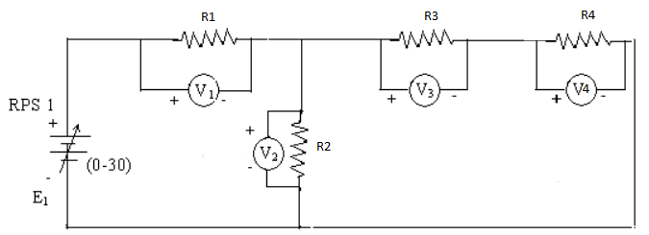

Figure 2 KVL Circuit Diagram

PROCEDURE: Resistances R1, R2, R3 and R4; and three voltmeters V1, V2 , V3 and V4are connected to DC battery or regulated power supply as shown in figure. Three rheostats are set their maximum values, supply is switched on and the reading of the voltmeters V1, V2, V3and V4 is noted. The process may be repeated by varying either of resistances R1, R2, R3 and R4.

OBSERVATIONS:

|  |  |  |  |  |  |  |  |
| --- | --- | --- | --- | --- | --- | --- | --- |
| Sr. No. | **Vs.** | **V1(Volts)** | V2(Volts) | V3(Volts) | V4(Volts) | Vs.=V1+V2 | V2=V3+V4 |
| 1 |  |  |  |  |  |  |  |
| 2 |  |  |  |  |  |  |  |
| 3 |  |  |  |  |  |  |  |
| 4 |  |  |  |  |  |  |  |

WORKING PRINCIPLE:

The sum of the emfs in any closed loop is equivalent to the sum of the potential drops in that loop, or: The algebraic sum of the products of the resistances of the conductors and the currents in them in a closed loop is equal to the total emf available in that loop. Similar to KCL, it can be stated as:



N is the total number of branches with currents flowing towards or away from the node. This law is based on the conservation of energy whereby voltage is defined as the energy per unit charge. The total amount of energy gained per unit charge must be equal to the amount of energy lost per unit charge, as energy and charge are both conserved.

KEY PARAMETERS: Let and also calculate the error.

EXPERIMENT RESULT:

1. Calculate the ideal voltages and currents for each element in the circuit and compare them to the measured values.
2. Compute the percentage error in the two measurements and provide a brief explanation for the error.

PRECAUTIONS:

* All connections should be tight.
* All steps should be followed carefully.
* Readings and calculation should be taken carefully.
* Don’t touch the live terminals.

QUESTIONS:

1. What is KVL?
2. What is ohm’s law?
3. Why voltmeters are connected in parallel to rheostats to measure voltage?
4. What is Fleming’s left hand rule?
5. What is Fleming’s right hand rule?



EXPERIMENT 3

AIM: To verify the Thevenin’s Theorem for the given circuit.

APPARATUS REQUIRED:

|  |  |  |  |  |
| --- | --- | --- | --- | --- |
| S. No. | Equipment | Specification | Quantity | Remark |
| 1. | Two regulated DC power  supply | 0-12V and 0-6V | 1 |  |
| 2. | PMMC Voltmeter | 0-10V | 1 |  |
| 3. | PMMC Ammeter | 0-5A | 1 |  |
| 4. | Resistances/Rheostats |  | 4/1 |  |
| 5. | Connecting Wires |  |  |  |

BRIEF THEORY: According to this theorem if a resistor of RL ohms be connected between any two terminals of a linear bilateral network, then the resulting current through load resistor will be equal to  where is the potential difference across these two points and  is the resistance of network measured between these two points.  is the open circuit voltage across the terminals, RTh is the equivalent resistance across the terminals , RL is the load resistance .

CIRCUIT DIAGRAM:

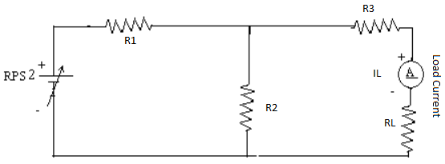

To find VTH

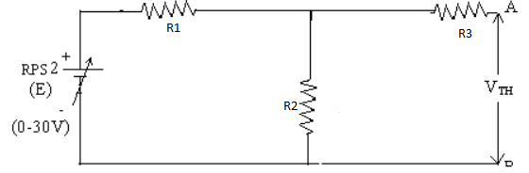

To find RTH

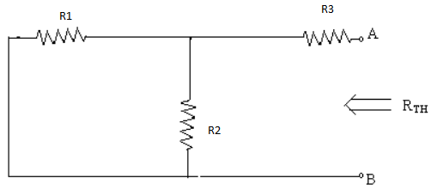

Thevenin’s Equivalent Circuits

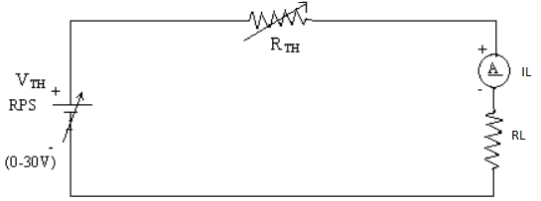

PROCEDURE:

* Remove the resistance (called Load Resistance RL).
* Find the open circuit voltage VOC which appears across the two terminals from where resistance is removed. It is also called Thevenin’s voltage .
* Compute the resistance of the whole network as looked into from these two terminals after all sources of e.m.f. are treated as short circuited while all the current sources are treated as open circuited.
* Connect RL back to its terminals from where previously it was removed and measure the current flow throughRL.
* Finally, calculate the current flowing through RL using the equation 

OBSERVATIONS:

|  |  |  |  |  |  |
| --- | --- | --- | --- | --- | --- |
| Sr. No. | Supply Voltage  Vs. | Load current  IL | Thevenin’s voltage  VTH | Equivalent resistance  RTH | Load Current  IL’’ |
| 1. |  |  |  |  |  |
| 2. |  |  |  |  |  |
| 3. |  |  |  |  |  |
| 4. |  |  |  |  |  |

CALCULATION: The load current 

RESULT AND DISCUSSION:

The value of open circuit voltage (VOC) is .....volts.

The value of Thevenin’s resistance is .....ohms.

The value of current acrossload is ......amps.

It will be found that measured value of current flowing through the load IL is the same as determined by Thevenin’s theorem.

PRECAUTIONS:

* 1. All connections should be tight.
  2. All steps should be followed carefully.
  3. Readings and calculation should be taken carefully.
  4. Don’t touch the live terminals.

QUESTIONS:

1. What do you mean by bilateral and unilateral circuits?
2. What is voltage source?
3. State of Thevenin’s theorem.
4. What is the utility of Thevenin’s theorem?



EXPERIMENT 4

AIM: To verify the Norton’s Theorem for the given circuit.

APPARATUS REQUIRED:

|  |  |  |  |
| --- | --- | --- | --- |
| S. No. | Equipment | Specification | Quantity |
| 1. | Two regulated DC power supply | 0-12V and 0-5A | 1 |
| 2. | PMMC Voltmeter | 0-10V | 1 |
| 3. | PMMC Ammeter | 0-5A | 1 |
| 4. | Resistances/Rheostats |  | 4/1 |
| 5. | Connecting Wires |  |  |

THEORY: According to this theorem if a resistor of RL ohms be connected between any two terminals of a linear bilateral network, then the resulting current through load resistor will be equal to  where is the short circuit current through load terminal points and  is the resistance of network measured between these two points. is the short circuit current through load terminal points, RN is the equivalent resistance across the terminals , RL is the load resistance .

CIRCUIT DIAGRAM:



To find VN =VTH



To find Isc

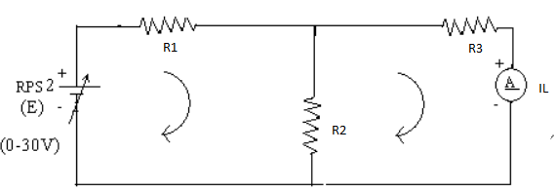

Norton’s Equivalent Circuit

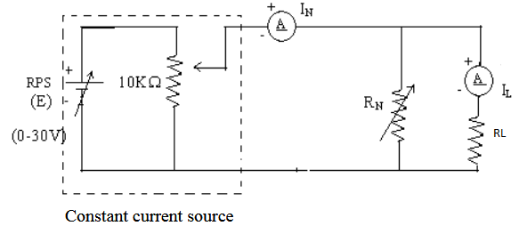

PROCEDURE:

* Remove the resistance (called Load Resistance RL).
* Find the short circuit current which flow through the short circuited two load terminals from where resistance is removed. It is also called short circuit current.
* Compute the resistance of the whole network as looked into from these two terminals after all sources of e.m.f. are treated as short circuited while all the current sources are treated as open circuited.
* Connect RL back to its terminals from where previously it was removed and measure the current flowing through RL.
* Finally, calculate the current flowing through RL using the equation



OBSERVATIONS:

|  |  |  |  |  |  |  |
| --- | --- | --- | --- | --- | --- | --- |
| Sr. No. | Supply Voltage  Vs. | Load current  IL | Norton voltage  VN | Short circuit current terminals | Equivalent resistance  RN | Load Current  IL’ |
| 1. |  |  |  |  |  |  |
| 2. |  |  |  |  |  |  |
| 3. |  |  |  |  |  |  |
| 4. |  |  |  |  |  |  |

CALCULATION: The load current 

RESULT AND DISCUSSION:

The value of short circuit crrent is .....Amp.

The value of Norton’s resistance is .....ohms.

It will be found that measured value of current flowing through the load IL is the same as determined by Norton’s theorem.

PRECAUTIONS:

* 1. All connections should be tight.
  2. All steps should be followed carefully.
  3. Readings and calculation should be taken carefully.
  4. Don’t touch the live terminals.

QUESTIONS:

1.State of Norton’s theorem.

2.What is the utility of Norton’s theorem?



EXPERIMENT 5

**AIM:** **To verify and observe the given waveform (Sinusoidal/Square/Triangular) and calculate its Frequency, Peak Value, Average Value, RMS Value and Form factor**

**APPARATUS REQUIRED:**

|  |  |  |  |
| --- | --- | --- | --- |
| S. No. | Equipment | Specification | Quantity |
| 1. | Function Generator | 50MHZ | 1 |
| 2. | CRO | 50MHZ | 1 |
| 3. | DC Power Supply | 0-30V | 1 |

THEORY:

The ratio between RMS value and Average value of an alternating quantity (Current or Voltage) is known as Form Factor. Form Factor in AC Circuit Sine wave.

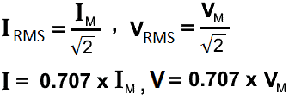

|  |  |  |  |
| --- | --- | --- | --- |
| Waveform Type | Formula for RMS Voltage | | Formula for Avg Voltage |
| Sine Wave | | VRMS = VPK/√2 | VAV = 0 |

Time Period T= (No. of small division) X (0.2) X(TIME/DIV) X (UNIT-10-3/10-6 Per second.

*0.2 =1 SMALL DIVISION VALUE.

*1 Capital block =1 Volt

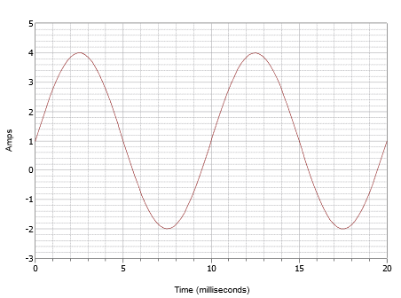

This waveform superficially may look like the one in Figure  , but don't let this fool you. First of all, the time scale is different. For this waveform, one cycle completes in 10 milliseconds. Therefore, the frequency is

f=1/T

=110ms

=100Hz

**PROCEDURE:**

1. Connect the CRO probes to output of function Generator.
2. Switch on the Function generator and CRO.
3. Observe the Sine waveform and measure its peak voltage, time period
   * 1. Calculate the Frequency,
     2. Peak Value, Average Value,
     3. RMS Value and Form factor of the Sine wave using the formula.
4. Repeat the experiment for different type of waveform (Triangular wave, square wave) and measure the listed parameters.
5. Trace the wave forms on butter paper with the help of pensile.
6. Past the butter paper left side of work file.
7. Verify frequency which is generated by function generator.

#### OBSERVATIONS TABLE:

|  |  |  |  |  |  |
| --- | --- | --- | --- | --- | --- |
| S. No. | Measurement | Verifying value | Sine Wave | Triangular Wave | Square Wave |
| 1 | Peak Voltage |  |  |  |  |
| 2 | Time Period |  |  |  |  |
| 3 | Frequency |  |  |  |  |

#### OBSERVATIONS:

Time (t) required for one cycle = number of div. × time/div

Unknown frequency, f = 1 / t

**CALCULATIONS:** Calculate the listed electrical parameters using formula.

#### PRECAUTIONS:

* All connections should be tight.
* All steps should be followed carefully.
* Readings and calculation should be taken carefully.

#### QUESTIONS:

1. What is the formula for RMS value?
2. How is average value different from RMS value?
3. What is Form factor?



EXPERIMENT 6

**AIM:** **To plot the V-I Characteristics of P-N Junction Diode and calculate the forward and reverse resistance of the Diode.**

**OBJECTIVE:** To study Volt-Ampere Characteristics of P-N Diode and also find cut-in voltage for P-N

Junction diode.

**APPARATUS REQUIRED:**

|  |  |  |
| --- | --- | --- |
| S. No. | Components/Equipment’s | Quantity |
| 1 | Diode (1N4007) | 1 |
| 2 | Resistor (1K) | 1 |
| 3 | Dual DC Regulated Power supply (0 - 30 V) | 1 |
| 4 | Digital Ammeters (0 - 200 mA, 0 - 200 µA) | 1 |
| 5 | Digital Voltmeter (0 - 20V) | 1 |
| 6 | Connecting wires | 1 |
| 7 | Bread board | 1 |

**THEORY:**

Operation: A PN junction diode is formed when a single crystal of semiconductor is doped with acceptors impurities (Pentavalent) on one side and donor impurities (Trivalent) on the other side. It has two terminals called electrodes, one each from P-region and N-region. Due to two electrodes, it is called (i.e., Di-electrode) Diode.

Biasing of PN junction Diode:

Applying external D.C. voltage to any electronic device is called biasing. There is no current in the unbiased PN junction at equilibrium. Depending upon the polarity of the D.C. voltage externally applied to diode, the biasing

is classified as forward biasing and Reverse biasing.

Forward bias operation: The P-N junction supports uni-directional current flow. If +ve terminal of the input

supply is connected to anode (P-side) and –ve terminal of the input supply is connected the cathode. Then diode

is said to be forward biased. In this condition the height of the potential barrier at the junction is lowered by an amount equal to given forward biasing voltage. Both the holes from p-side and electrons from n-side cross the junction simultaneously and constitute a forward current from n-side cross the junction simultaneously and constitute a forward current (injected minority current – due to holes crossing the junction and entering P- side

of the diode). Assuming current flowing through the diode to be very large, the diode can be approximated as

short- circuited switch.

Reverse bias operation: If negative terminal of the input supply is connected to anode (p-side) and –ve terminal

of the input supply is connected to cathode (n-side) then the diode is said to be reverse biased. In this condition

an amount equal to reverse biasing voltage increases the height of the potential barrier at the junction. Both the holes on P-side and electrons on N-side tend to move away from the junction there by increasing the depleted region. However, the process cannot continue indefinitely, thus a small current called reverse saturation current continues to flow in the diode. This current is negligible; the diode can be approximated as an open circuited switch.

Diode current equation: The volt-ampere characteristics of a diode explained by the following equations:

http://i.imgur.com/HQOC5uX.gif

I = current flowing in the diode, I0 = reverse saturation current

V = Voltage applied to the diode

VT = volt- equivalent of temperature = k T/q = T/ 11,600 = 26mV (@ room temp)

http://i.imgur.com/sFdxwNw.gif=1 (for Ge) and 2 (for Si). It is observed that Ge diodes has smaller cut-in-voltage when compared to Si diode. The reverse saturation current in Ge diode is larger in magnitude when compared to silicon diode.

**CIRCUIT DIAGRAM:**

Forward Bias Condition: Forward Bias Condition is given as

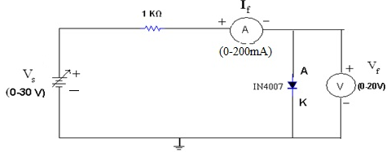

**Figure: Forward Bias Connection**

Reversed Bias Condition: Reversed Bias Condition is given as:

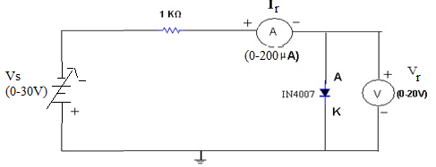

**Figure: Reverse Biased Connection**

**PROCEDURE:**

**Forward Bias Condition:**

Connect the circuit as shown in figure (1) using PN Junction diode.

Initially vary Regulated Power Supply (RPS) voltage Vs in steps of 0.1 V. Once the current starts increasing vary Vs from 1V to 12V in steps of 1V and note down the corresponding readings Vf and If.

Tabulate different forward currents obtained for different forward voltages.

Reverse Bias Condition:

Connect the circuit as shown in figure (2) using PN Junction diode.

Vary Vs in the Regulated Power Supply (RPS) gradually in steps of 1V from 0V to 12V and note down the corresponding readings Vr and Ir.

Tabulate different reverse currents obtained for different reverse voltages.

To get the graph in reverse region (theoretically), remove voltmeter and with reference to the supply voltage note down the reverse current readings in Ammeter because current always selects low reactance path.(Diode have infinite resistance in reverse bias ideally).To get the graph in reverse region (theoretically), replace voltmeter with nano ammeter. Voltmeter has less load resistance when compared to diode. Current conducts in low resistance path.

**OBSERVATIONS:**

**Forward Bias Condition:**

|  |  |  |  |  |
| --- | --- | --- | --- | --- |
| Sr. N0. | RPS Voltage Vs(volts) | Forward Voltage across the diode Vf (volts) | Forward Current through the diode If (mA) | |
| 1 |  |  | |  |
| 2 |  |  | |  |
| 3 |  |  | |  |
| 4 |  |  | |  |
| 5 |  |  | |  |
| 6 |  |  | |  |
| 7 |  |  | |  |
| 8 |  |  | |  |
| 9 |  |  | |  |
| 10 |  |  | |  |

**Reverse Bias Condition:**

|  |  |  |  |  |
| --- | --- | --- | --- | --- |
| Sr. N0. | RPS Voltage Vs(volts) | Forward Voltage across the diode Vf (volts) | Forward Current through the diode If (mA) | |
| 1 |  |  | |  |
| 2 |  |  | |  |
| 3 |  |  | |  |
| 4 |  |  | |  |
| 5 |  |  | |  |
| 6 |  |  | |  |
| 7 |  |  | |  |
| 8 |  |  | |  |
| 9 |  |  | |  |
| 10 |  |  | |  |

**Graph:**

Take a graph sheet and divide it into 4 equal parts. Mark origin at the center of the graph sheet.

Now mark +ve X-axis as Vf, -ve X-axis as Vr, +ve Y-axis as If and –ve Y-axis as Ir.

Mark the readings tabulated for Si forward biased condition in first Quadrant and Si reverse biased condition in third Quadrant.

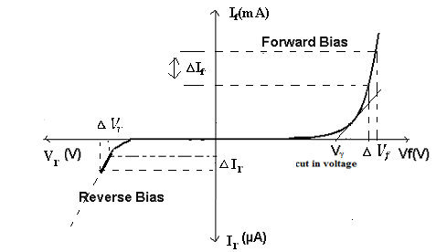

**Fig: V- I Characteristics of PN Junction Diode under Forward & Reverse Bias Conditions**

**PRECAUTIONS**:

1. While doing the experiment do not exceed the readings of the diode. This may lead to damaging of the diode.
2. Connect voltmeter and ammeter in correct polarities as shown in the circuit diagram.
3. Do not switch ON the power supply unless you have checked the circuit connections as per the circuit diagram.

**QUESTIONS**:

1. What are trivalent and pentavalent impurities?
2. How PN junction diode does acts as a switch?
3. What is diode current equation?
4. What is the value of Vt at room temperature?
5. Dynamic resistance expression?



EXPERIMENT 7

**AIM:** **To plot the V-I Characteristics and Verification of Regulation action of ZENER Diode, for forward and reverse resistance of the Diode.**

**OBJECTIVE**: To plot the Volt-Ampere Characteristics of Zener Diode and also find Zener Breakdown Voltage in Reverse Biased conditions and observe the regulation action.

**APPARATUS REQUIRED:**

|  |  |  |
| --- | --- | --- |
| S. No. | Components/Equipment’s | Quantity |
| 1 | Zener Diodes (1N4735A) | 1 |
| 2 | Resistors (1Khttp://i.imgur.com/6fz6IHX.gif, 3.3http://i.imgur.com/6fz6IHX.gif) | 1 |
| 3 | Dual DC Regulated Power supply (0 - 30 V) | 1 |
| 4 | Digital Ammeters (0 - 200 mA, 0 - 200 µA) | 1 |
| 5 | Digital Voltmeter (0 - 20V) | 1 |
| 6 | Connecting wires | 1 |
| 7 | Bread board | 1 |

**THEORY:**

A Zener diode is a highly doped semiconductor device specifically designed to function in the reverse direction. It is engineered with a wide range of Zener voltages (Vz), and certain types are even adjustable to achieve variable voltage regulation.

  Zener diodes, which enable the flow of current in both forward and reverse directions. As one of the most widely used semiconductor diodes, Zener diodes play a crucial role in electronic circuits. This article provides an in-depth exploration of Zener diodes, covering their explanation, definition, operation in reverse bias, breakdown mechanisms (avalanche breakdown and Zener breakdown), circuit symbol, V-I characteristics, and specifications. Additionally, we delve into the applications of Zener diodes and address frequently asked questions for a comprehensive understanding of this essential electronic component.

**Working in reverse bias**

A Zener diode functions similarly to a regular diode when forward-biased. However, in reverse-biased mode, a small leakage current flows through the diode. As the reverse voltage increases and reaches the predetermined breakdown voltage (Vz), current begins to flow through the diode. This current reaches a maximum level determined by the series resistor, after which it stabilizes and remains constant across a wide range of applied voltages.

There are two types of breakdowns in a Zener Diode:

**Avalanche Breakdown and Zener Breakdown**.

Avalanche breakdown occurs in both normal diodes and Zener diodes when subjected to high reverse voltage. When a significant reverse voltage is applied to the PN junction, the free electrons gain enough energy to accelerate at high velocities. These high-velocity electrons collide with other atoms, causing the ejection of additional electrons. This continuous collision process generates a large number of free electrons, resulting in a rapid increase in electric current through the diode. In the case of a normal diode, this sudden surge in current could permanently damage it. However, a Zener diode is specifically designed to withstand avalanche breakdown and can handle the sudden current spike. Avalanche breakdown typically occurs in Zener diodes with a Zener voltage (Vz) greater than 6V.

### Zener Breakdown in Zener Diode

When the reverse bias voltage applied to a Zener diode approaches its Zener voltage, the electric field within the depletion region becomes strong enough to attract and remove electrons from their valence band. These valence electrons, energized by the intense electric field, break free from their parent atoms. This phenomenon takes place in the Zener breakdown region, where even a slight increase in voltage leads to a rapid surge in electric current.

**CIRCUIT DIAGRAM:**

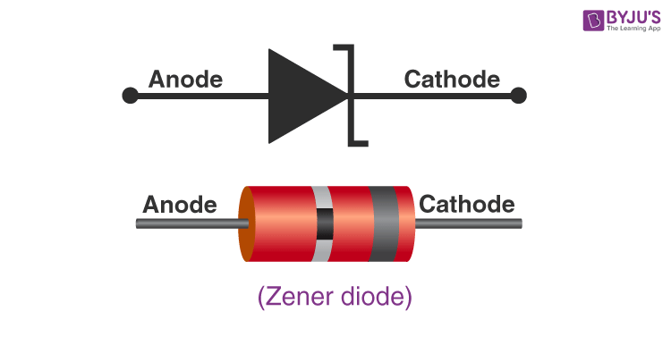

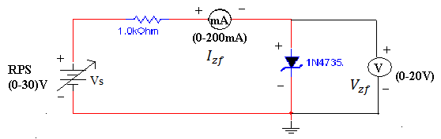 **Figure: Forward Bias Condition**

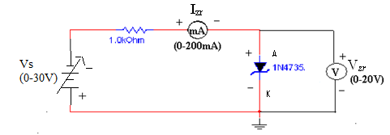

**Figure: Reverse Bias Condition**

**PROCEDURE:**

A) Forward Bias Condition:

Connect the circuit as shown in figure (1).

Initially vary Vs in steps of 0.1V. Once the current starts increasing vary Vs in steps of 1V up to 12V. Note down the corresponding readings of Vzf and Izf.

B) Reverse Bias Condition:

Connect the circuit as shown in figure (2).

Vary Vsgradually in steps of 1V up to 12V and note down the corresponding readings of Vzr and Izr.

Tabulate different reverse currents obtained for different reverse voltages.

**OBSERVATIONS:**

Table: 1 Forward Bias Condition:

|  |  |  |  |
| --- | --- | --- | --- |
| Sr. N0. | RPS Voltage Vs(volts) | Forward Voltage across the diode Vf (volts) | Forward Current through the diode If (mA) |
| 1 |  |  |  |
| 2 |  |  |  |
| 3 |  |  |  |
| 4 |  |  |  |
| 5 |  |  |  |
| 6 |  |  |  |
| 7 |  |  |  |
| 8 |  |  |  |
| 9 |  |  |  |
| 10 |  |  |  |

Table: 2 Reverse Bias Condition:

|  |  |  |  |
| --- | --- | --- | --- |
| Sr. N0. | RPS Voltage Vs(volts) | Forward Voltage across the diode Vf (volts) | Forward Current through the diode If (mA) |
| 1 |  |  |  |
| 2 |  |  |  |
| 3 |  |  |  |
| 4 |  |  |  |
| 5 |  |  |  |
| 6 |  |  |  |
| 7 |  |  |  |
| 8 |  |  |  |
| 9 |  |  |  |
| 10 |  |  |  |

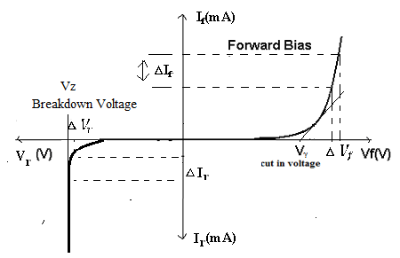

**Fig: V- I Characteristics of Zener Diode under Forward & Reverse Bias Conditions**

**KEY PARAMETERS:**

1. Breakdown Voltage = 5.1V
2. Power dissipation = 0.75W
3. Max Forward Current = 1A
4. EXPERIMENT RESULT:
5. Calculate the ideal voltages and currents for each element in the circuit and compare them to the measured values.
6. Compute the percentage error in the two measurements and provide a brief explanation for the error.
7. Give the explanation regarding the error in terms of different causes etc.
8. Explain the behavior of the graph and why it is so?

**PRECAUTIONS:**

1. While doing the experiment do not exceed the readings of the diode. This may lead to damaging of the diode.
2. Connect voltmeter and ammeter in correct polarities as shown in the circuit diagram.
3. Do not switch ON the power supply unless you have checked the circuit connections as per the circuit diagram.

**QUESTIONS:**

1. What is the doping concentration in Zener diodes?
2. Can we use Zener diode as a switch?
3. What is PIV of Zener?



EXPERIMENT 8

**AIM:** **To verify the working of Half and Full Wave Rectifier Circuit and calculate its efficiency.**

**OBJECTIVE:** To verify the working of Half and Full Wave Rectifiers Circuit (Bridge Rectifier) and calculate it’s efficiency.

#### APPARATUS REQUIRED:

|  |  |  |  |
| --- | --- | --- | --- |
| S. No. | Components/Equipment’s | Quantity | Remarks |
| 1 | CRO | 1 |  |
| 2 | Multimeter | 1 |  |
| 3 | Trainer Kit | 1 |  |
| 4 | Bread Board | 1 |  |
| 5 | Connecting wires |  |  |
| 6 | Diode | 4 |  |
| 7 | Power Supply | 1 |  |

**THEORY:**

Half-wave rectifiers transform AC voltage to DC voltage. A halfwave rectifier circuit uses only one diode for the transformation. A halfwave rectifier is defined as a type of rectifier that allows only one-half cycle of an AC voltage waveform to pass while blocking the other half cycle. In this session, let us know in detail about the half-wave rectifier.

Electric circuits that convert AC to DC are known as rectifiers. Rectifiers are classified into two types as Half Wave Rectifiers and Full Wave Rectifiers. Significant power is lost while using a half-wave rectifier and is not feasible for applications that need a smooth and steady supply. For a more smooth and steady supply, we use the full wave rectifiers. In this article, we will be looking into the working and characteristics of a full wave rectifier.

### Half Wave Rectifier Circuit

A half-wave rectifier is the simplest form of the rectifier and requires only one diode for the construction of a halfwave rectifier circuit.

A halfwave rectifier circuit consists of three main components as follows:

* A diode
* A transformer
* A resistive load

**Given below is the half-wave rectifier diagram:**

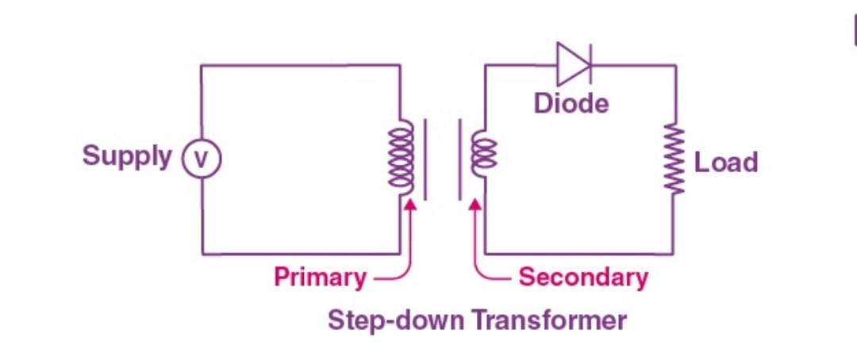

### Working of Half Wave Rectifier

In this section, let us understand how a half-wave rectifier transforms AC into DC.

1. A high AC voltage is applied to the primary side of the step-down transformer. The obtained secondary low voltage is applied to the diode.
2. The diode is forward biased during the positive half cycle of the AC voltage and reverse biased during the negative half cycle.
3. The final output voltage waveform is as shown in the figure below:

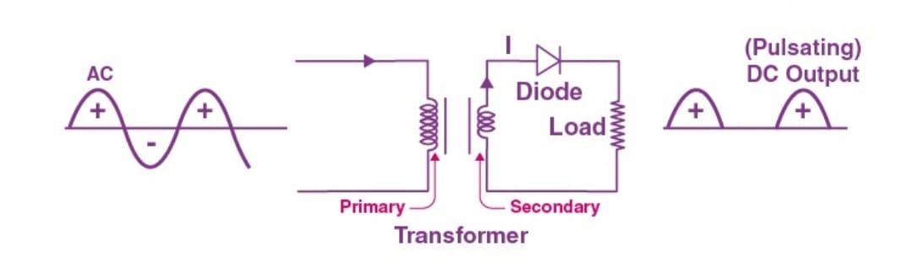

For better understanding, let us simplify the half-wave circuit by replacing the secondary transformer coils with a voltage source as shown below:

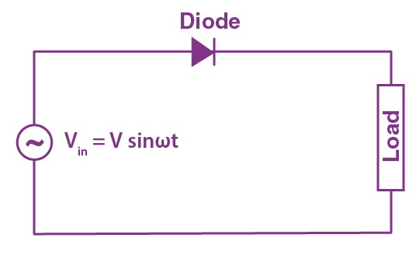

For the positive half cycle of the AC source voltage, the circuit effectively becomes as shown below in the diagram:

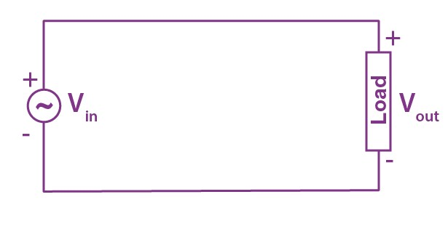

When the diode is forward biased, it acts as a closed switch. But, during the negative half cycle of the AC source voltage, the equivalent circuit becomes as shown in the figure below

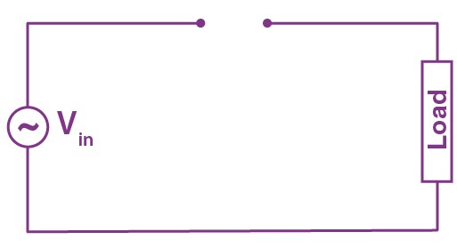

When a diode is reverse biased, it acts as an open switch. Since no current can flow to the load, the output voltage is equal to zero.

### Half Wave Rectifier Waveform

The halfwave rectifier waveform before and after rectification is shown below in the figure.

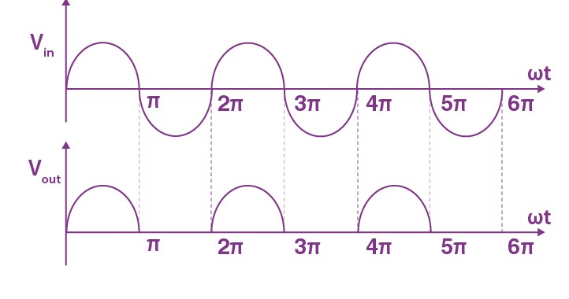

### Efficiency of Halfwave Rectifier:

The efficiency of a halfwave rectifier is the ratio of output DC power to the input AC power.

The efficiency formula for halfwave rectifier is given as follows;

\(\begin{array}{l}\eta = \frac{ P _ { D C } }{ P _ { A C } } \end{array} \)

## Full Wave Rectifier:

A full wave rectifier is defined as a rectifier that converts the complete cycle of alternating current into pulsating DC.

Unlike halfwave rectifiers that utilize only the halfwave of the input AC cycle, full wave rectifiers utilize the full cycle. The lower efficiency of the half wave rectifier can be overcome by the full wave rectifier.

### Full Wave Rectifier Circuit

The circuit of the full wave rectifier can be constructed in two ways. The first method uses a centre tapped transformer and two diodes. This arrangement is known as a centre tapped full wave rectifier. The second method uses a standard transformer with four diodes arranged as a bridge. This is known as a bridge rectifier. In the next section, we will restrict the discussion to the centre tapped full wave rectifier only. You can read our article on [bridge rectifier](https://byjus.com/physics/bridge-rectifier/) to learn the construction and working of bridge rectifier in detail.

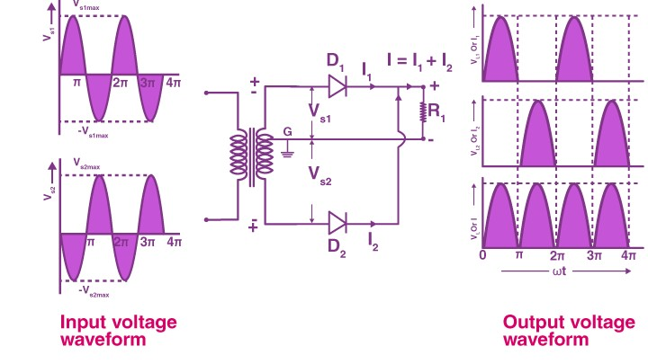

The circuit of the full wave rectifier consists of a step-down transformer and two diodes that are connected and centre tapped. The output voltage is obtained across the connected load resistor.

### Working of Full Wave Rectifier

The input AC supplied to the full wave rectifier is very high. The step-down transformer in the rectifier circuit converts the high voltage AC into low voltage AC. The anode of the Centre tapped diodes is connected to the transformer’s secondary winding and connected to the load resistor. During the positive half cycle of the alternating current, the top half of the secondary winding becomes positive while the second half of the secondary winding becomes negative.

During the positive half cycle, diode D1 is forward biased as it is connected to the top of the secondary winding while diode D2 is reverse biased as it is connected to the bottom of the secondary winding. Due to this, diode D1 will conduct acting as a short circuit and D2 will not conduct acting as an open circuit

During the negative half cycle, the diode D1 is reverse biased and the diode D2 is forward biased because the top half of the secondary circuit becomes negative and the bottom half of the circuit becomes positive. Thus, in a full wave rectifier, DC voltage is obtained for both positive and negative half cycle.

### Rectification Efficiency:

The rectification efficiency of the full-wave rectifier can be obtained using the following formula:

The efficiency of the full wave rectifiers is 81.2%

**Observation:-** Observe the wave shape of output signal of FWR on the CRO.

#### Observation Table:-

|  |  |  |
| --- | --- | --- |
| SR. NO. | Applied Input Voltage | Observe Output Voltage |
| 1 |  |  |
| 2 |  |  |
| 3 |  |  |
| 4 |  |  |

**Calculation:-**

Ripple Factor of FWR = ac voltage at o/p / dc voltage at o/p=

**Results:**

1. The output dc voltage is little less than the theoretical value.
2. There is little difference between theoretical & measured value of ripple Factor



EXPERIMENT 9

**AIM:** **To plot the input and output characteristics of Bipolar Junction Transistor (BJT) in Common Emitter connection.**

**OBJECTIVE**: To obtain input resistance find http://i.imgur.com/99B7RaO.gifVBE and http://i.imgur.com/99B7RaO.gifIB for a constant **VCE** on one of the input characteristics and output resistance find http://i.imgur.com/99B7RaO.gif**IC** and http://i.imgur.com/99B7RaO.gif**VCB** at a constant **IB.**

**APPARATUS REQUIRED:**

|  |  |  |  |
| --- | --- | --- | --- |
| **S. No.** | **Components/Equipments** | **Quantity** | **Remarks** |
| 1 | Transistor BC 107 | 1 |  |
| 2 | Resistors (1Khttp://i.imgur.com/6fz6IHX.gif, 100Khttp://i.imgur.com/6fz6IHX.gif) | 1 |  |
| 3 | Dual DC Regulated Power supply (0 - 30 V) | 1 |  |
| 4 | Digital Ammeters  ( 0 - 200 mA, 0 - 200 µA) | 1 |  |
| 5 | Digital Voltmeter (0 - 20V) | 1 |  |
| 6 | Connecting wires | 1 |  |
| 7 | Bread board | 1 |  |

**THEORY:**

The basic circuit diagram for studying input characteristics is shown in the circuit diagram. The input is applied between base and emitter, the output is taken between collector and emitter. Here emitter of the transistor is common to both input and output and hence the name Common Emitter Configuration.

Input characteristics are obtained between the input current and input voltage at constant output voltage. It is plotted between **VBE** and **IB** at constant **VCE** in CE configuration.

Output characteristics are obtained between the output voltage and output current at constant input current. It is plotted between **VCE** and **IC** at constant **IB** in CE configuration.

**CIRCUIT DIAGRAM:**

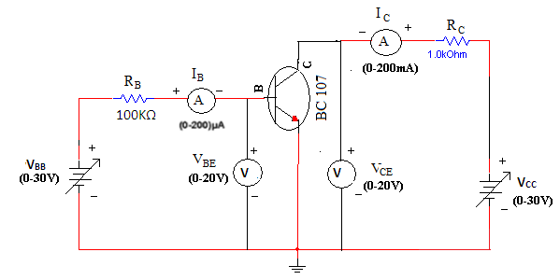

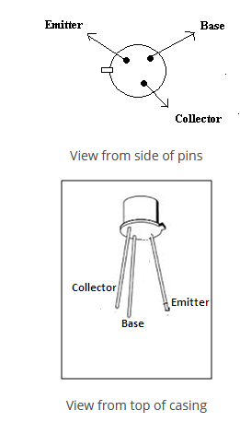

**PROCEDURE:**

**Input Characteristics:**

1. Connect the circuit as shown in the circuit diagram.
2. Keep output voltage **VCE** = 0V by varying **VCC**.
3. Varying **VBB** gradually, note down base current **IB** and base-emitter voltage **VBE**.
4. Step size is not fixed because of non linear curve. Initially vary **VBB** in steps of 0.1V. Once the current starts increasing vary **VBB** in steps of 1V up to 12V.
5. Repeat above procedure (step 3) for **VCE** = 5V.

**Output Characteristics:**

1. Connect the circuit as shown in the circuit diagram.
2. Keep emitter current **IB** = 20http://i.imgur.com/YoyOvED.gifA by varying **VBB**.
3. Varying **VCC** gradually in steps of 1V up to 12V and note down collector current **IC** and Collector-Emitter Voltage (**VCE**).
4. Repeat above procedure (step 3) for **IB** = 60µA, 0µA.

**OBSERVATIONS:**

|  |  |  |  |  |
| --- | --- | --- | --- | --- |
| **Input Characteristics** | | | | |
| **VBB (Volts)** | **VCE = 0V** | | **VCE = 5V** | |
| **VBE(Volts)** | **IB(µA)** | **VBE(Volts)** | **IB(µA)** |
|  |  |  |  |  |
|  |  |  |  |  |
|  |  |  |  |  |
|  |  |  |  |  |
|  |  |  |  |  |
|  |  |  |  |  |

|  |  |  |  |  |  |  |
| --- | --- | --- | --- | --- | --- | --- |
| **Output Characteristics** | | | | | | |
| **VCC (Volts)** | **IB = 0 µA** | | **IB = 20 µA** | | **IB = 40 µA** | |
| **VCE(Volts)** | **IC(mA)** | **VCE(Volts)** | **IC(mA)** | **VCE(Volts)** | **IC(mA)** |
|  |  |  |  |  |  |  |
|  |  |  |  |  |  |  |
|  |  |  |  |  |  |  |

**GRAPH:**

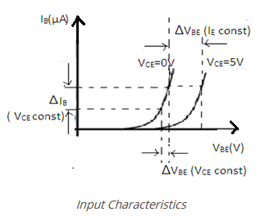

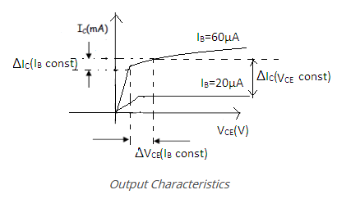

1. Plot the input characteristics by taking **VBE** on X-axis and **IB** on Y-axis at a constant **VCE** as a constant parameter.
2. Plot the output characteristics by taking **VCE** on X-axis and taking **IC** on Y-axis taking **IB** as a constant parameter.

**KEY PARAMETERS:**

* Max Collector Current = 0.1A
* VCEO max = 50V

EXPERIMENT RESULT:

1. Calculate the ideal voltages and currents for each element in the circuit and compare them to the measured values.
2. Compute the percentage error in the two measurements and provide a brief explanation for the error.
3. Give the explanation regarding the error in terms of different causes etc.
4. Explain the behavior of the graph and why it is so?

**PRECAUTIONS:**

1. While performing the experiment do not exceed the ratings of the transistor. This may lead to damage the transistor.
2. Connect voltmeter and ammeter in correct polarities as shown in the circuit diagram.
3. Do not switch ON the power supply unless you have checked the circuit connections as per the circuit diagram.
4. Make sure while selecting the emitter, base and collector terminals of the transistor.

**QUESTIONS:**

1. Can transistor be replaced by two back-to-back connected diodes?
2. For amplification CE is preferred, why?
3. What is the range β of a BJT?



**CONCLUSIONS**

After completion of basic electrical and electronics lab, students are able to

* Handle of basic electrical and electronics equipment’s
* Do staircase wiring on bread board.
* Understand domestic wiring procedures.
* Analyze KCL and KVL in any circuit.
* Simplify the circuits using Thevenin and Norton theorem.
* Analyze and draw the characteristics of PN diode, Zener diode, BJT in common base emitter.



**PROBLEM STATEMENTS**

* According to the passive sign convention, power assumes a positive sign when the current enters the positive polarity of the voltage across an element.
* Two elements are in series when they are connected sequentially, end to end. When elements are in series, the same current flows through them. They are in parallel if they are connected to the same two nodes. Elements in parallel always have the same voltage across them.
* Source transformation is a procedure for transforming a voltage source in series with a resistor to a current source in parallel with a resistor, or vice versa.
* The efficiency is only 50% when maximum power transfer is achieved, but approaches 100% as the load resistance approaches infinity, though the total power level tends towards zero. Efficiency also approaches 100% if the source resistance approaches zero, and 0% if the load resistance approaches zero.
* Silicon diodes have a forward voltage of approximately 0.7 volts. Germanium diodes have a forward voltage of approximately 0.3 volts. The maximum reverse-bias voltage that a diode can withstand without “breaking down” is called the Peak Inverse Voltage, or PIV rating.

If the turns ratio is equal to unity, n = 1 then both the primary and secondary have the same number of windings, therefore the voltages and currents are the same for both windings.



**Statement of Mini Projects**

Verification of KCL and KVL in the presence of resistive circuit, resistive and inductive circuit with AC supply source